**Python Django Internship Report**

**Personal Details**

**Name :** Patel Vruditkumar Dasharathbhai

**Enrollment Number :** 181250107045

**College Name :** Shree Swaminarayan Institute of

Technology ( SSIT, Bhat )

**Degree :** B.E. in Computer Engineering

**Semester :** 7

**Github URL :** [**https://github.com/Vruditdp**](https://github.com/Vruditdp)

**Company Details**

**Company Name :** Akash Technolabs

**External Guide :** Akash Padhiyar

**Training Duration :** 26-05-2021 to 21-06-2021

**Call on**  : 9978621654

**Website :** [**http://www.akashtechnolabs.com**](http://www.akashtechnolabs.com)

**Address :** 202 Aarya Arcade above Passport office

Mithakhali six road, Navarangpura,

Ahmedabad.



**Index**

|  |  |  |
| --- | --- | --- |
| Sr. No. | Task Details | Page Number |
|  |  |  |
| 1 | Registration form using HTML & CSS | 4 |
| 2 | Basics of Python programming language | 6 |
| 3 | Conditional statements, Input from user and basic operation on variables | 8 |
| 4 | Arithmatic & Logical Operators and Functions | 12 |
| 5 | Problem Solving using Functions. | 15 |
| 6 | CRUD Operation in Python. | 21 |
| 7 | Selenium | 24 |
| 8 | Django Basics | 26 |
| 9 | HTML Pages and Theme Integration in Django | 32 |
| 10 | Login (authentication)feature in website | 37 |
| 11 | Admin panel and database (sqlite3) | 39 |

1. **Registration Form using HTML & CSS**

* On the very first day of internship, I made one registration form using HTML and CSS.
* I also add some beautiful animation between SignIn and SignUp page at the same time with back-ground image.
* Here is the screen shot of my code :

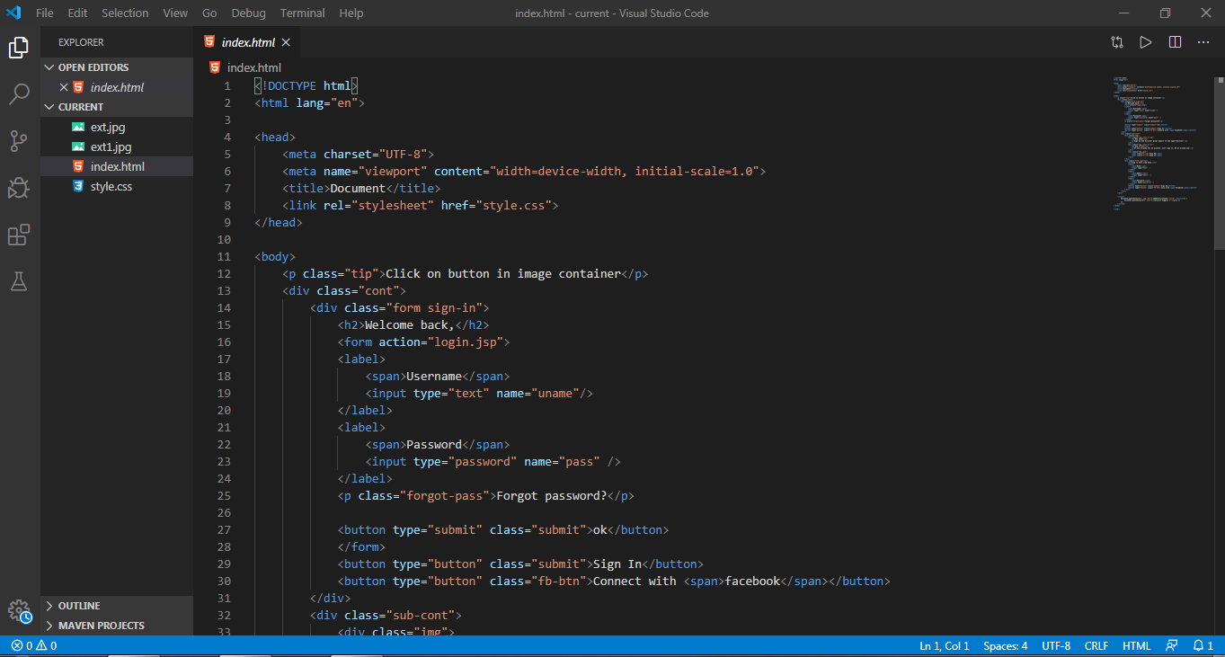

Output :

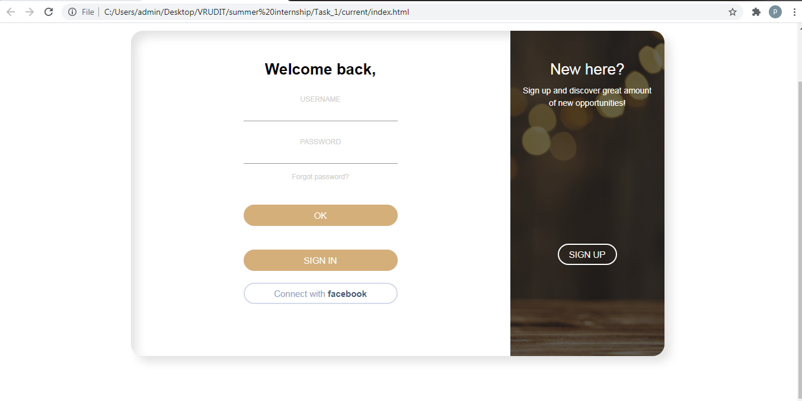

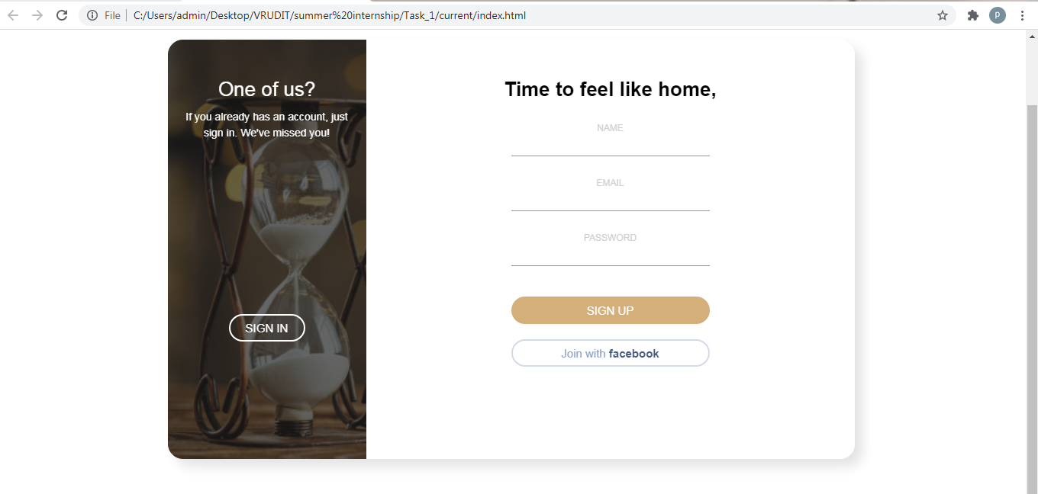

**2. Basics of Python programming language :**

On second day , I was given to perform some basic operation of python language.

It includes :

* Comment
* Print()
* Variable declaration
* Type(). Isinstance()
* List, dictionary
* Slicing of list and sting

Here are some screen shots:

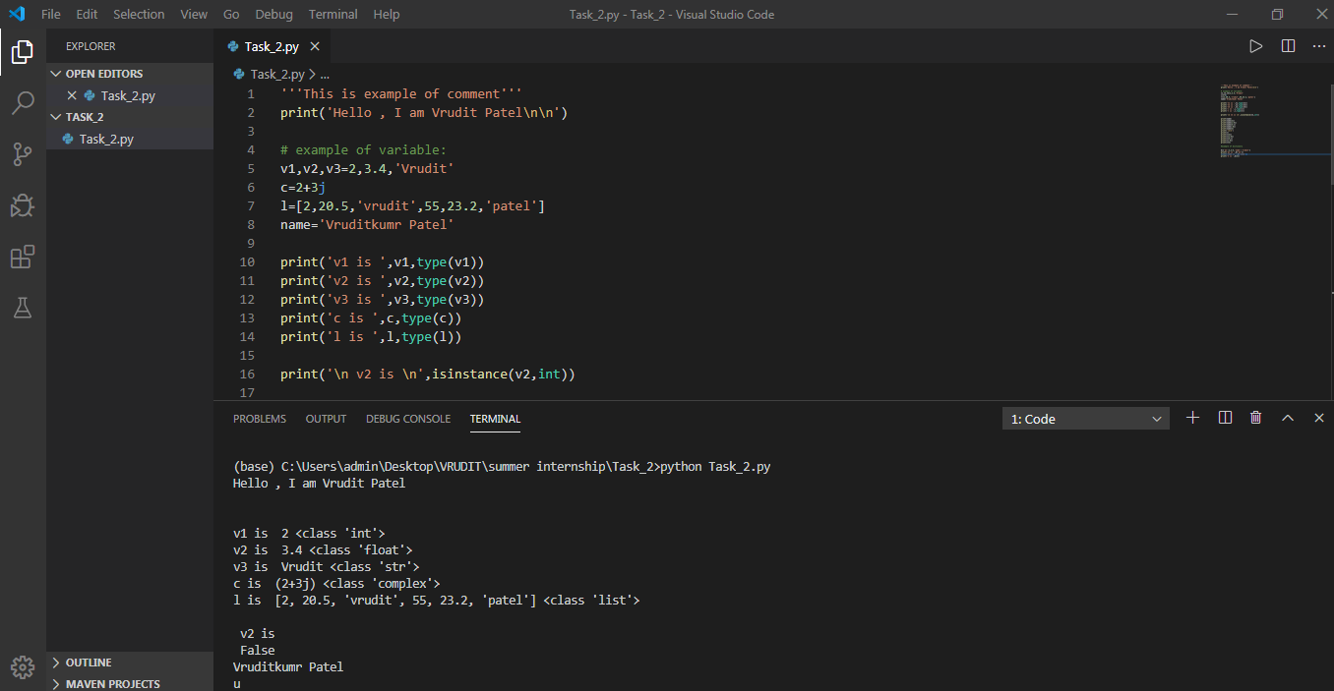

**OUTPUT :**

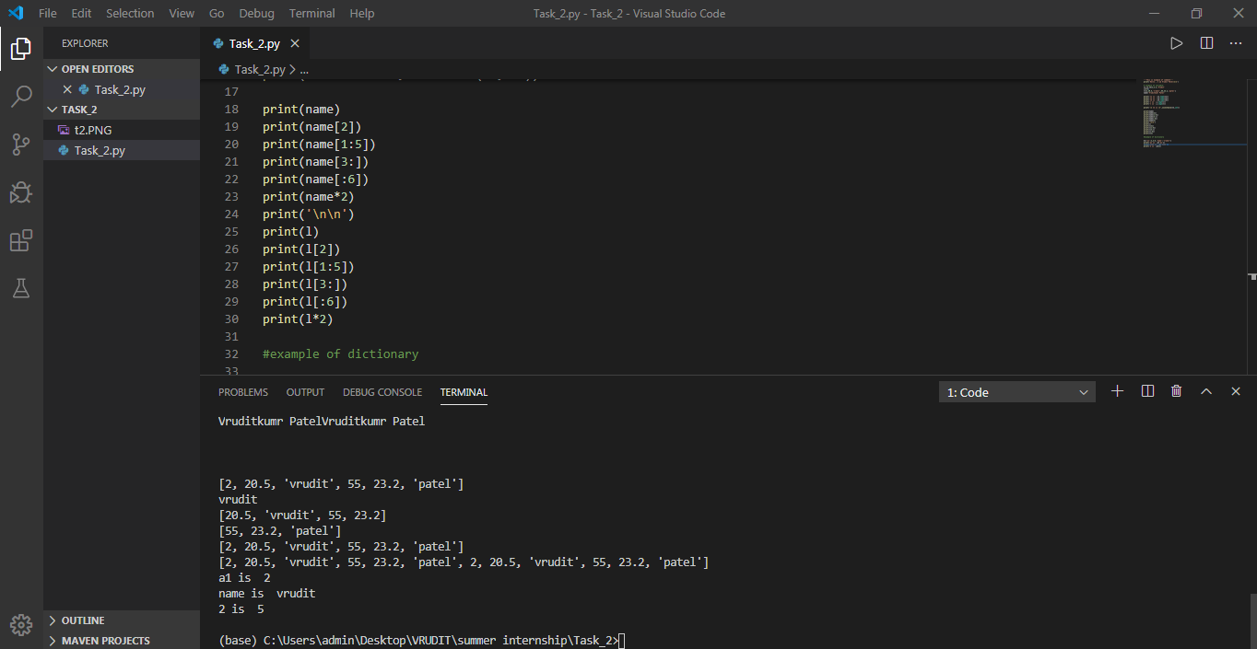

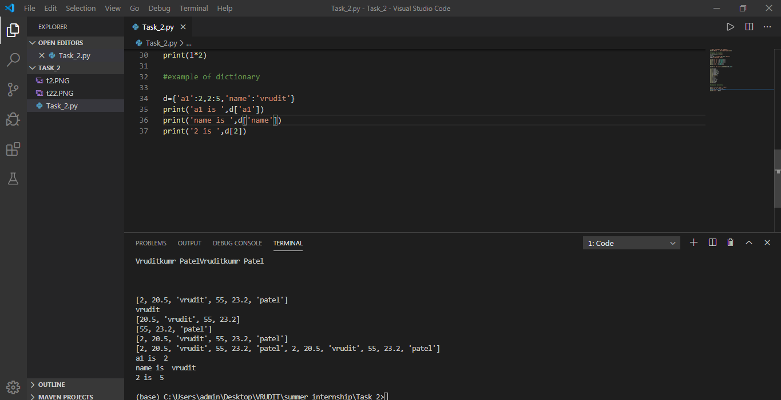

1. **Conditional statements, Input from user and basic operation on variables :**

On the third day, we were given to perform various operation on variables that are taken by user.

We have to implement Conditional statements like :

* If
* If … Else
* Elif
* While
* Do … While

Here are some screen shots of tasks :

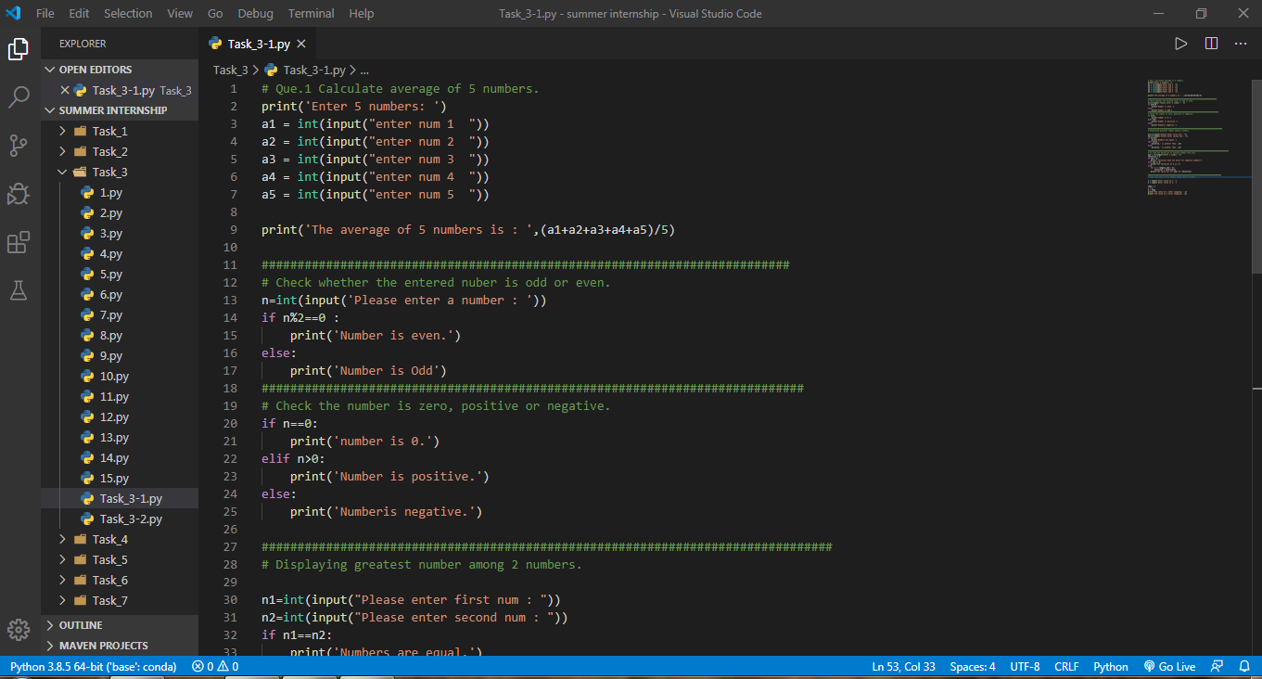

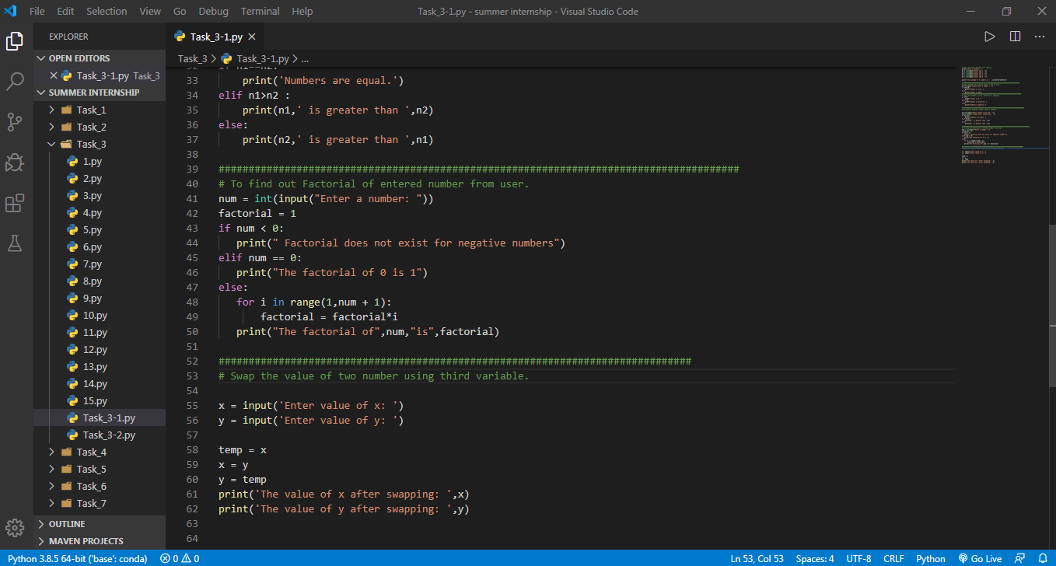

**OUTPUT :**

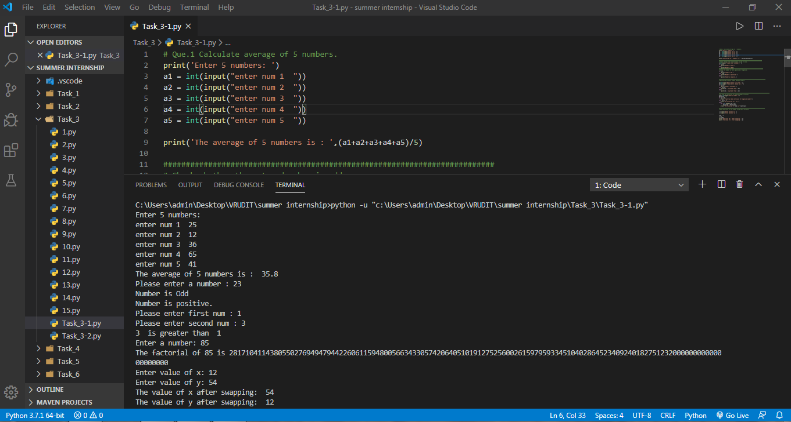

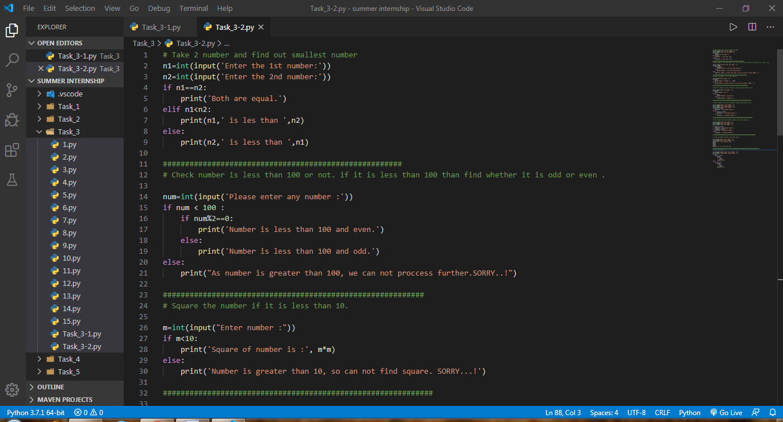

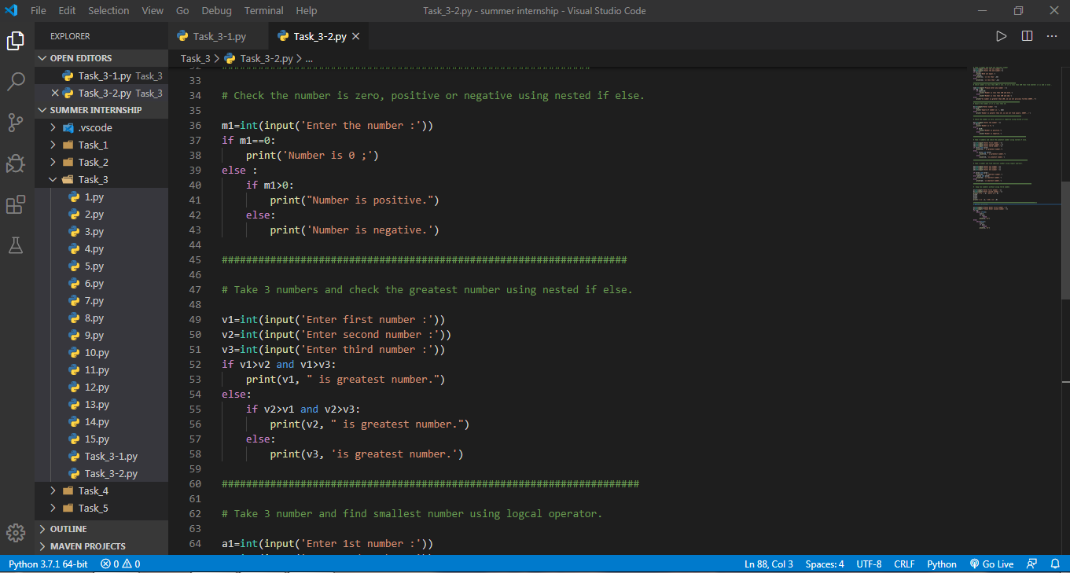

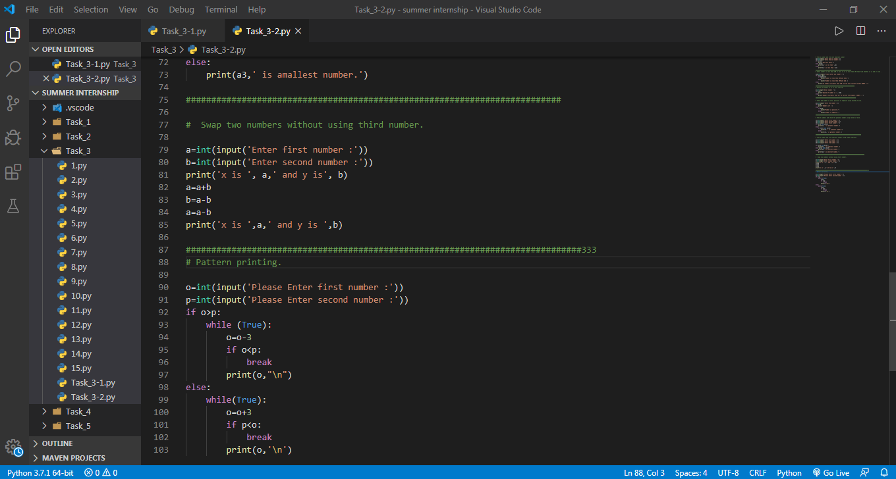

**OUTPUT :**

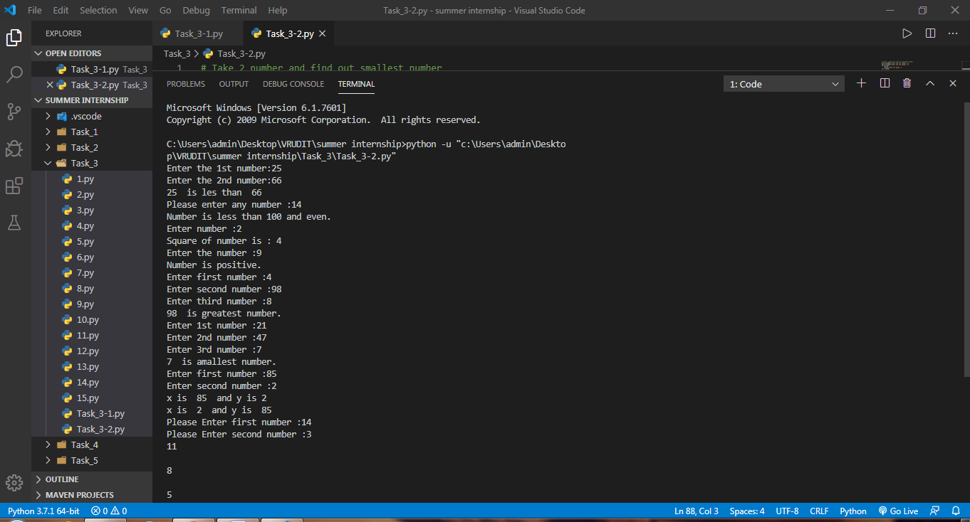

**4. Arithmatic & Logical Operators and Functions**

On that day we learnt very crucial topic of Python – **Functions** .

We did some practical of different kind of functions .

* + function with arguments
  + function without arguments
  + function with arguments and return type.
  + function with arguments but from another module.
  + function from another arguments without arguments
  + function with arguments and return type from another module

Apart from this , I also learned different kind of Operators.

* + Comparison
  + Arithmatic
  + Logical
  + Special Operators ( "is" and "in" )

Here are some screen shots :

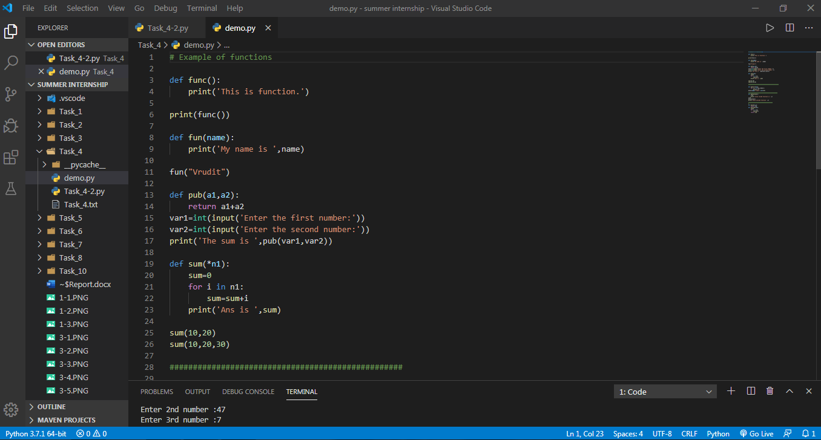

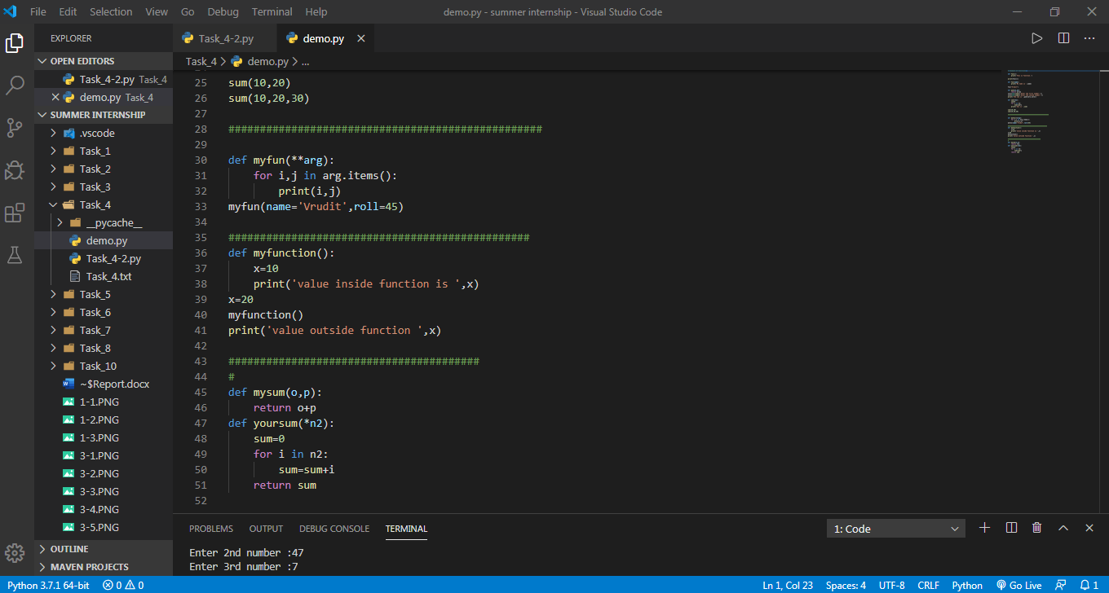

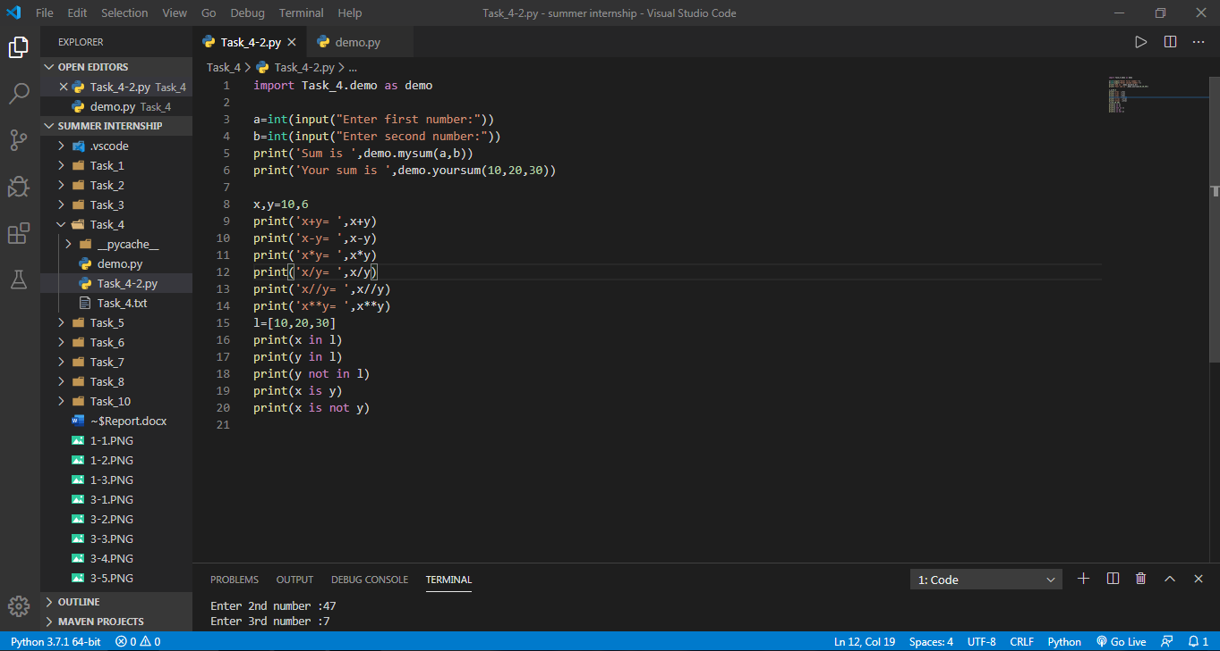

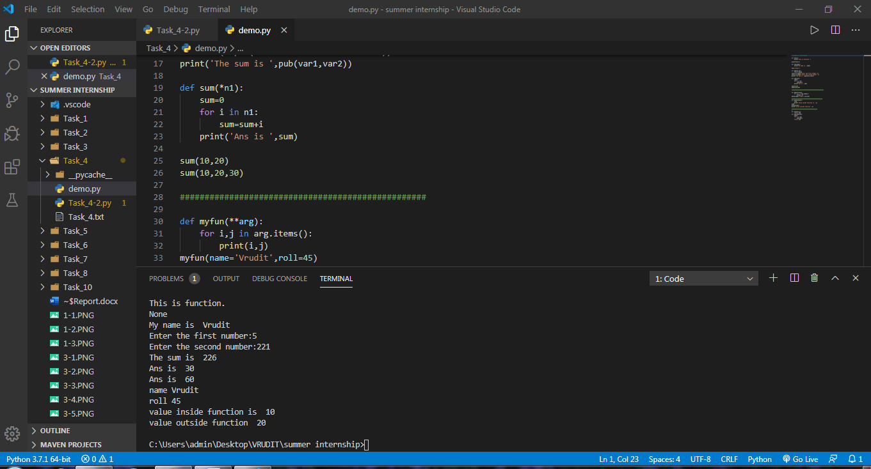

Output :

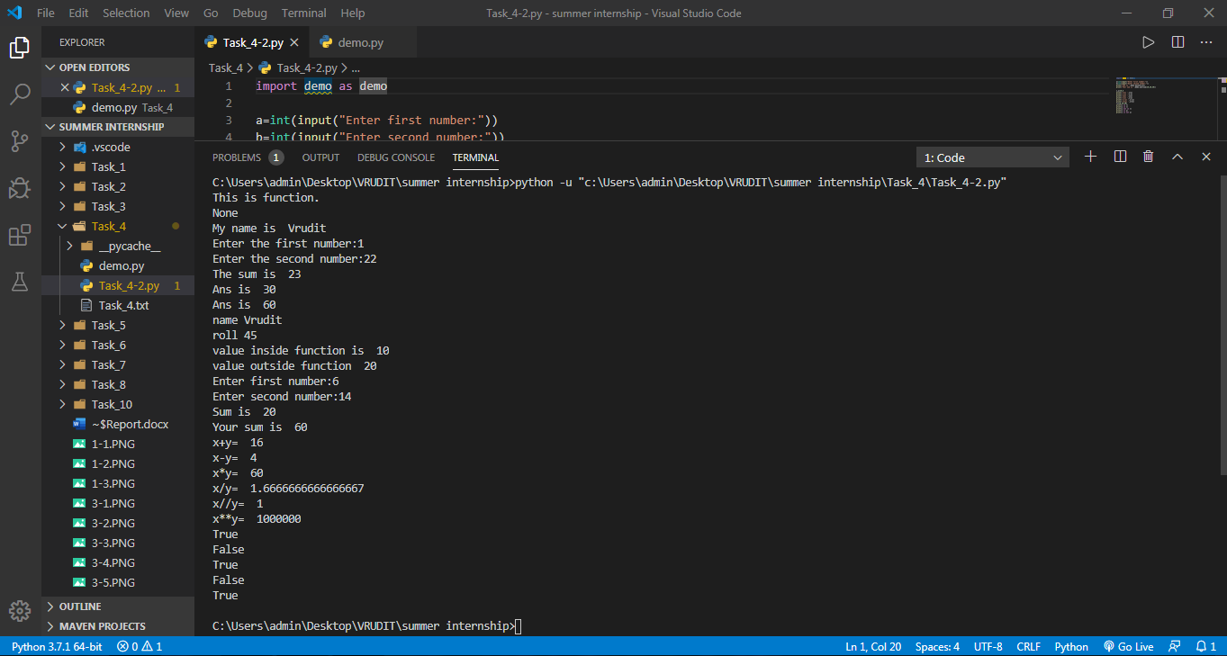

**5 . Problem Solving using Functions. ( OOP’s )**

* We were to solve some problems with the help of OOP’s concepts.

Those problems were :

1. Create a class cal1 that will calculate sum of three numbers. Create setdata() method which has three parameters that contain numbers. Create display() method that will calculate sum and display sum.

2. Create a class cal2 that will calculate area of a circle. Create setdata() method that should take radius from the user. Create area() method that will calculate area . Create display() method that will display area

3. Create a class cal3 that will calculate simple interest. Create constructor method which has three parameters .Create calInterest() method that will calculate Interest . Create display() method that will display Interest.

4. Create a class cal4 that will calculate square of a number. Create setdata() method which has one parameters that contain number. Create display() method that will calculate sum.(Function should return value)

5. Consider an employee class, which contains fields such as name and designation. And a subclass, which contains a field salary. Write a program for inheriting this relation.

6. Create a class cal5 that will calculate area of a rectangle. Create constructor method which has two parameters .Create calArea() method that will calculate area of a rectangle. Create display() method that will display area of a rectangle.

7. Create a class cal6 that will calculate area of a square. Create setdata() method that should take length from the user. Create area() method that will calculate area . Create display() method that will display area .

8. Write a program with use of inheritance: Define a class publisher that stores the name of the title. Derive two classes book and tape, which inherit publisher. Book class contains member data called page no and tape class contain time for playing. Define functions in the appropriate classes to get and print the details.

9. Create a class called scheme with scheme_id, scheme_name,outgoing_rate, and message_charge. Derive customer class form scheme and include cust_id, name and mobile_no data.Define necessary functions to read and display data.

10. Create a arith class. The class should have a parameterized constructor and methods to add, subtract and multiply two numbers and to return the answers.

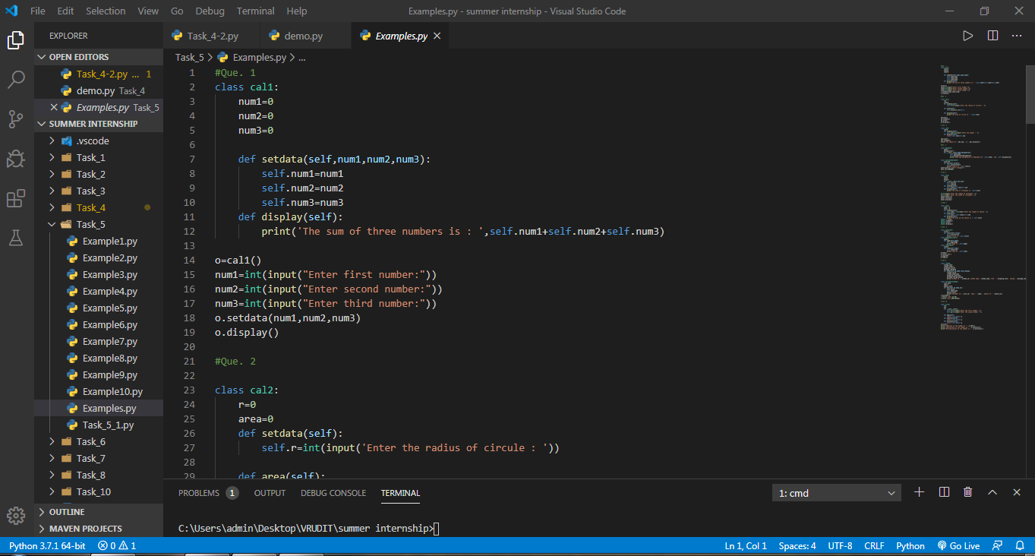

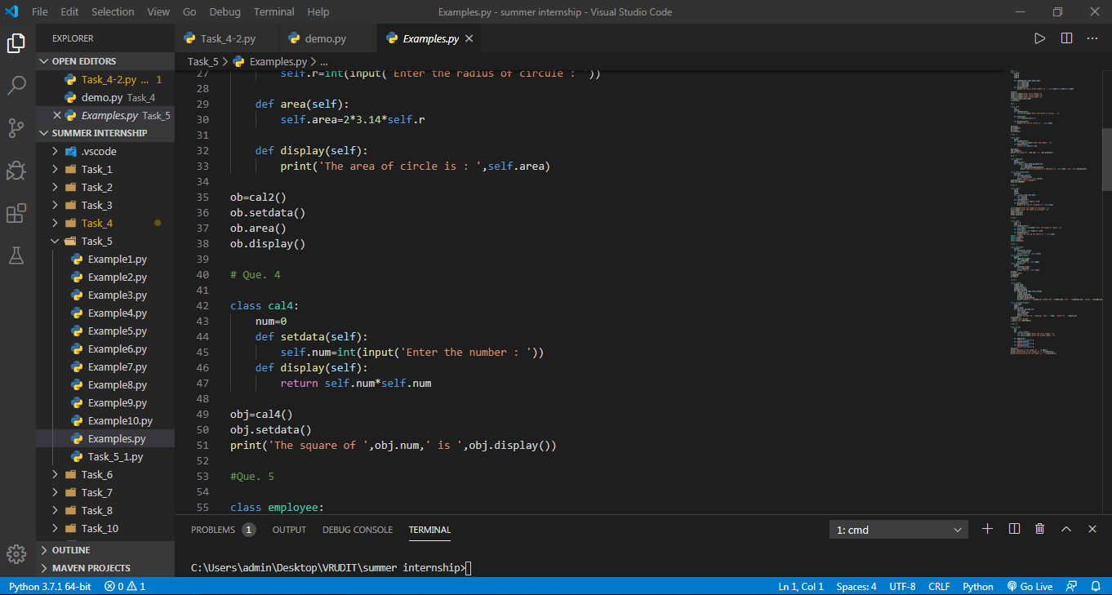

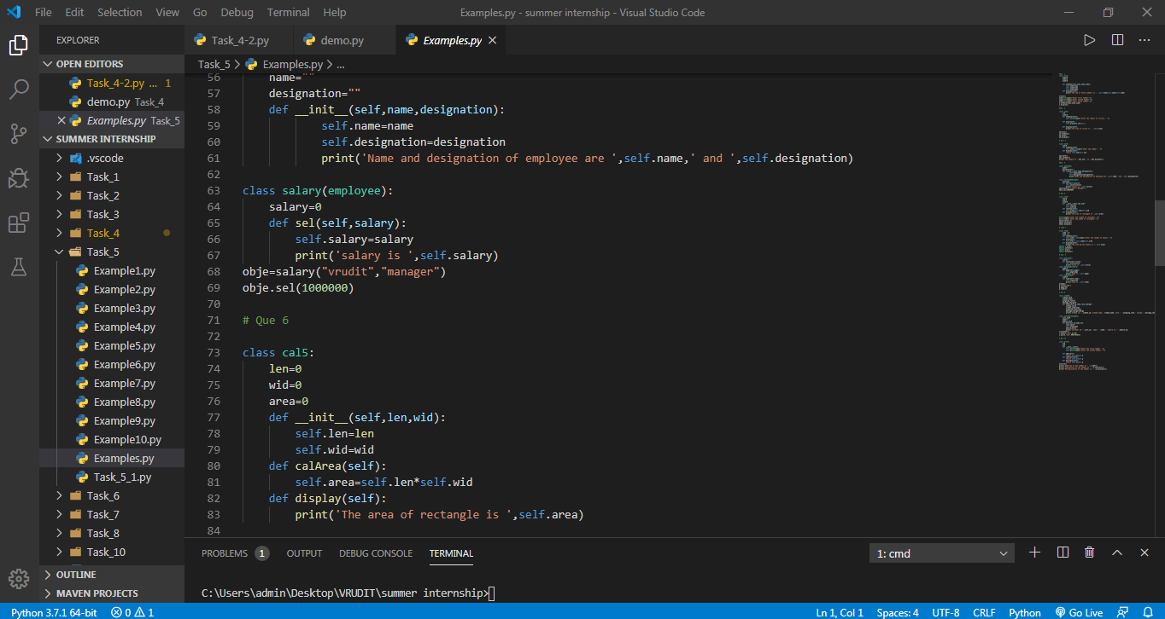

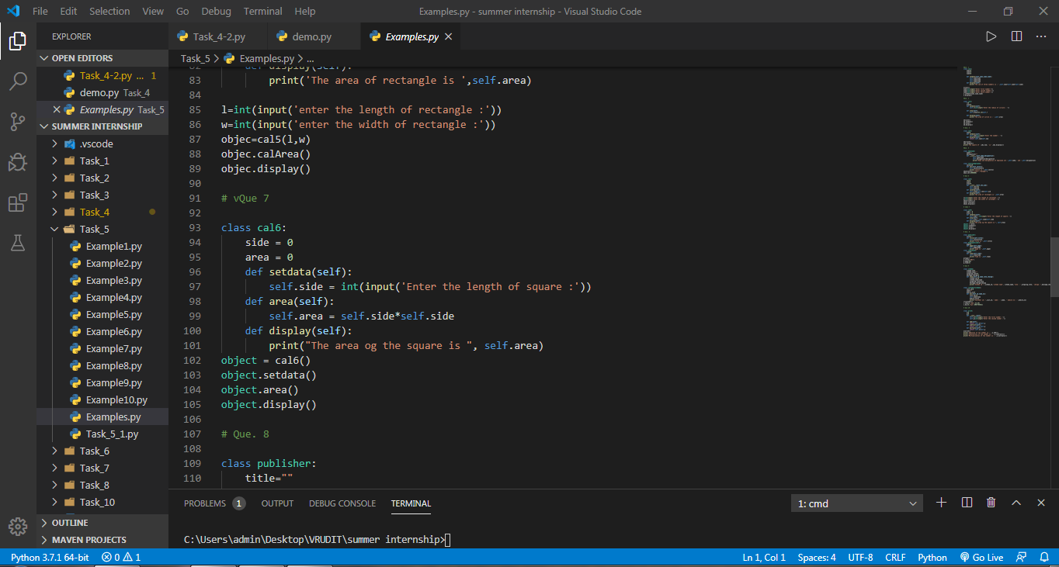

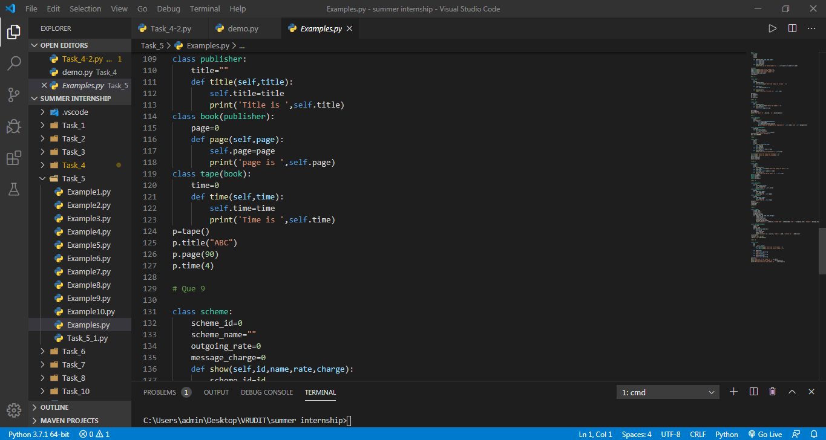

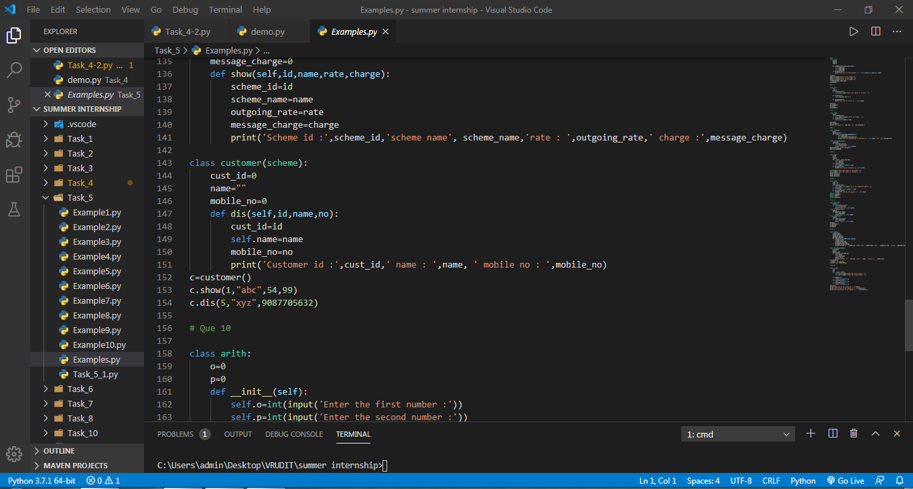

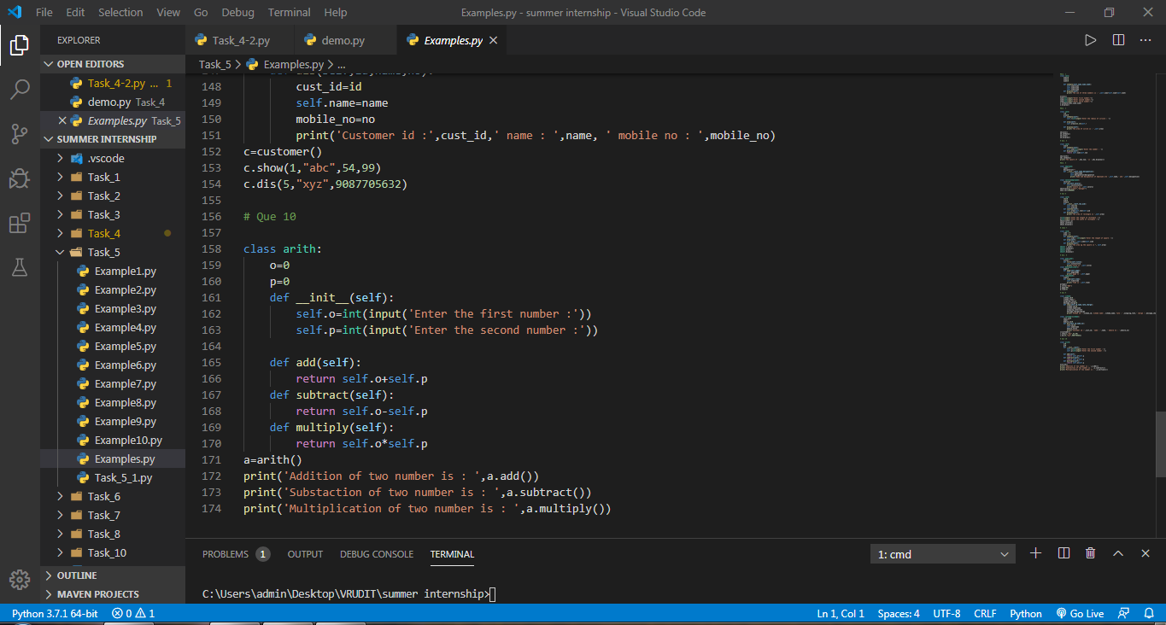

**NOTE** : Here I have run all functions via single file. So I got output on single terminal consol.

**OUTPUT :**

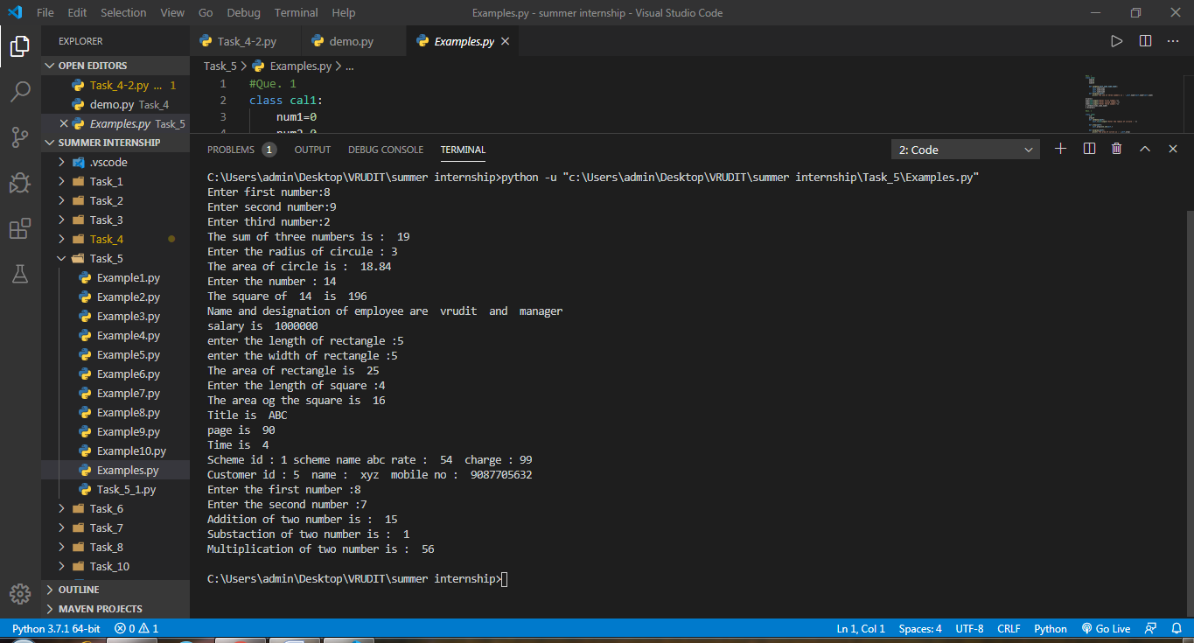

**6. CRUD Operation in Python.**

* **CRUD** Operations are the most fundamental concepts of any scripting language. i.e Java, Python, Ruby, PHP etc.
* We learnt how to implement CRUD in python.
* In this programe Implement Database connectivity with MySql using MySql connector.

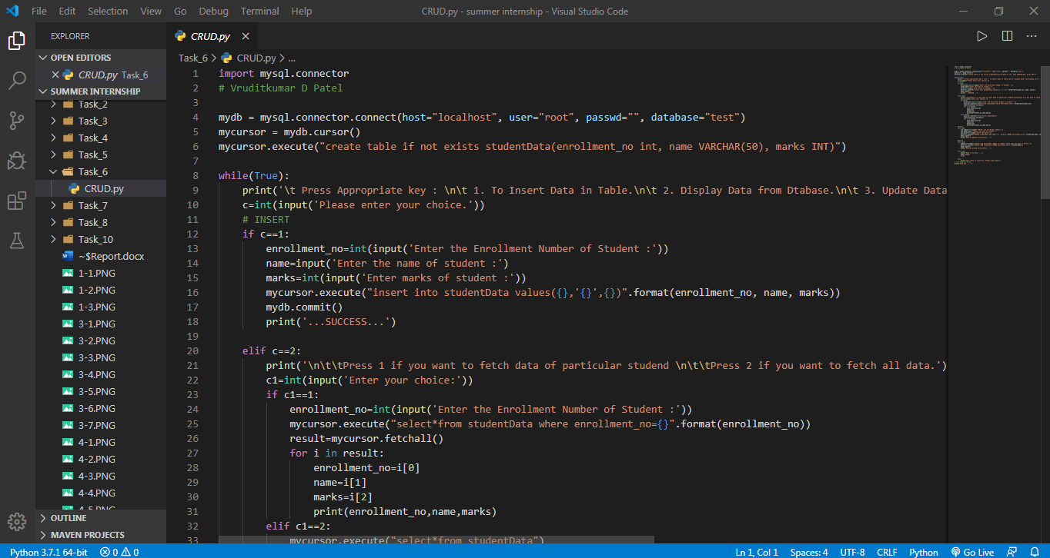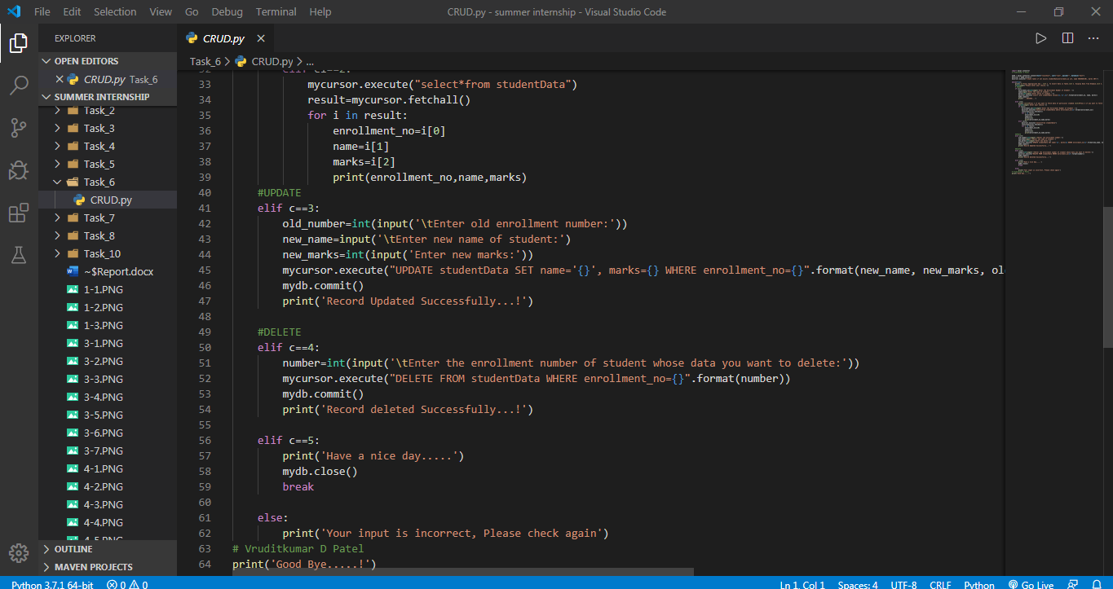

Output :

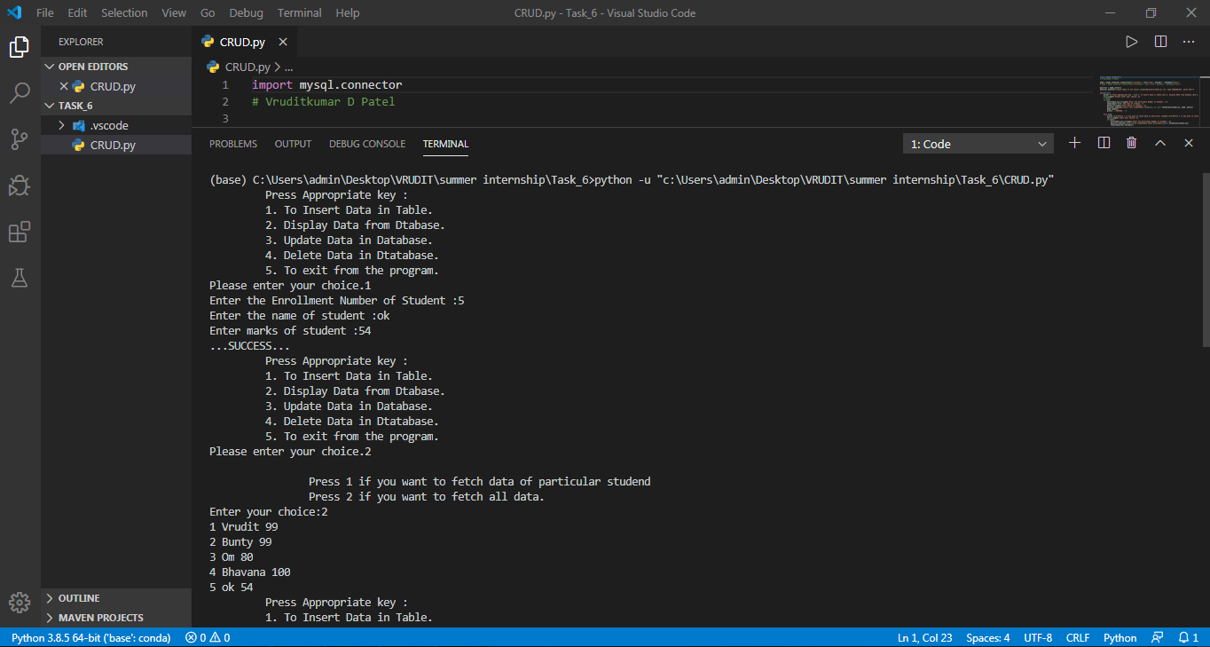

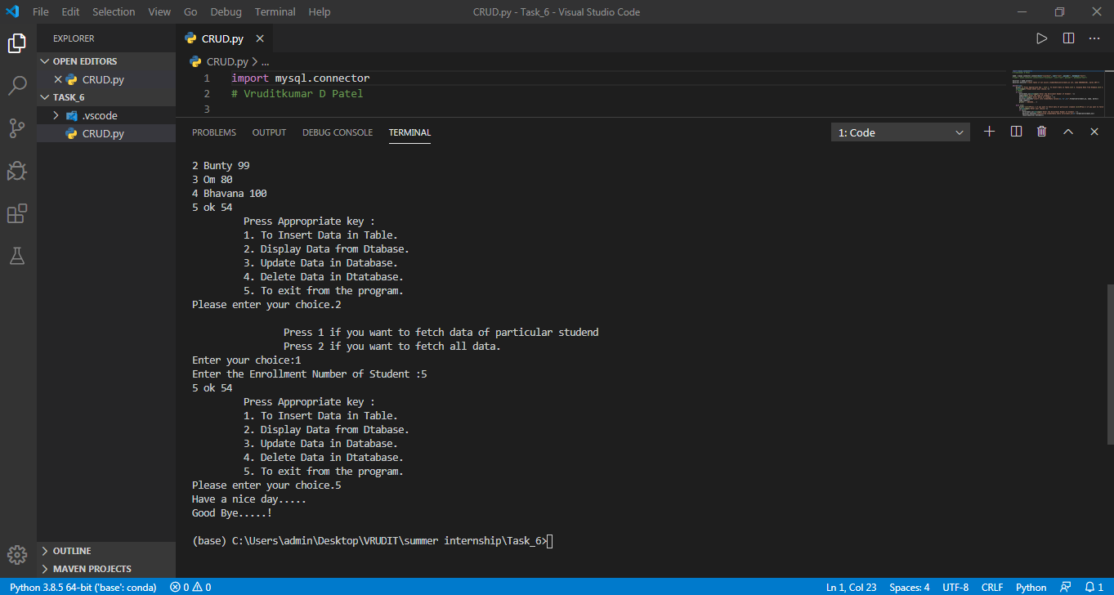

**7. Selenium**

* The main function of selenium library is to test the software, However, we can also use selenium for implementation of automation using Python.
* In that session I learnt basic fundamentals of selenium and how to automatically search anything on Google using selenium.

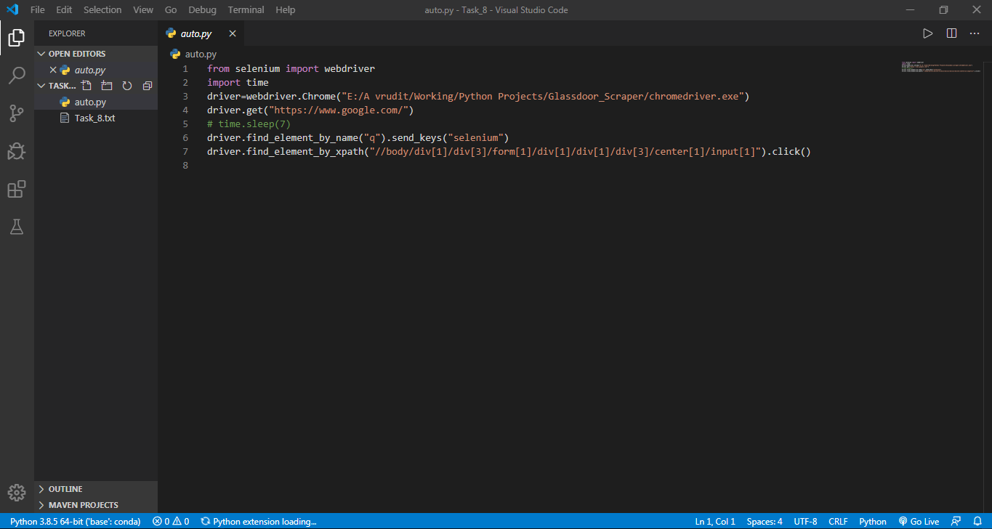

**OUTPUT :**

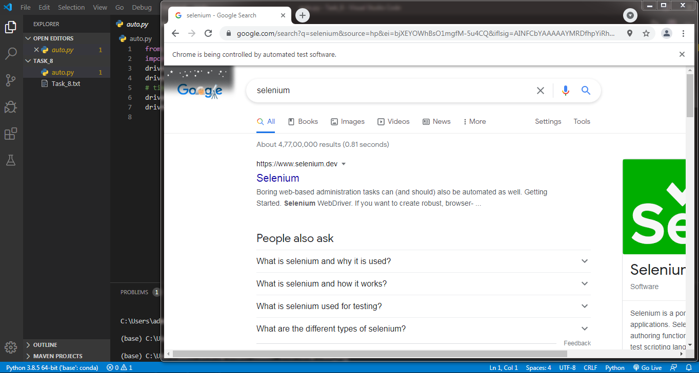

**8.** **Django Basic**

* We learnt how to download django using pip command.
* Apart from this we also got to know how to make application inside django project using command prompt.
* How to run django server using “ python manage.py runserver ” .
* We can make any changes and we can register all those in settings.py file in main project folder.
* Whatever change we make, we have to define that in views.py and register in urls.py.
* As our app is register in our main project folder, every change in our app reflects in our main project.
* “ python manage.py runserver ” runs the django server on localhost at port number 8000.
* We can change port number as well.

Flie structure of django project :

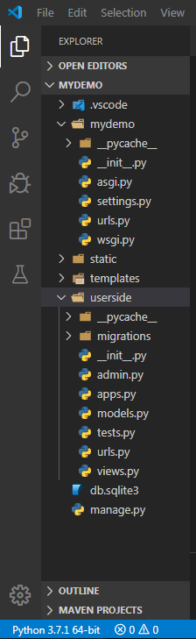

**manage.py :**

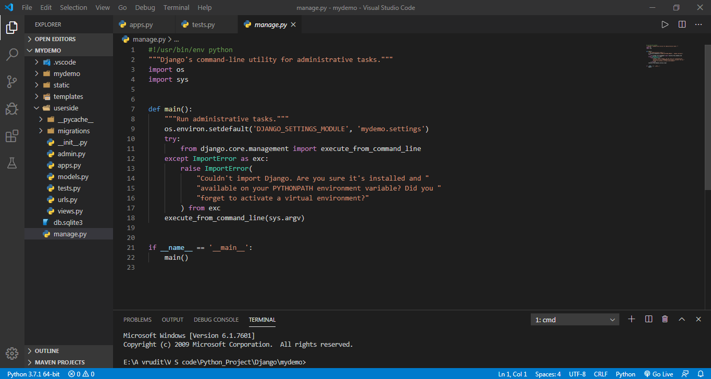

**urls.py :**

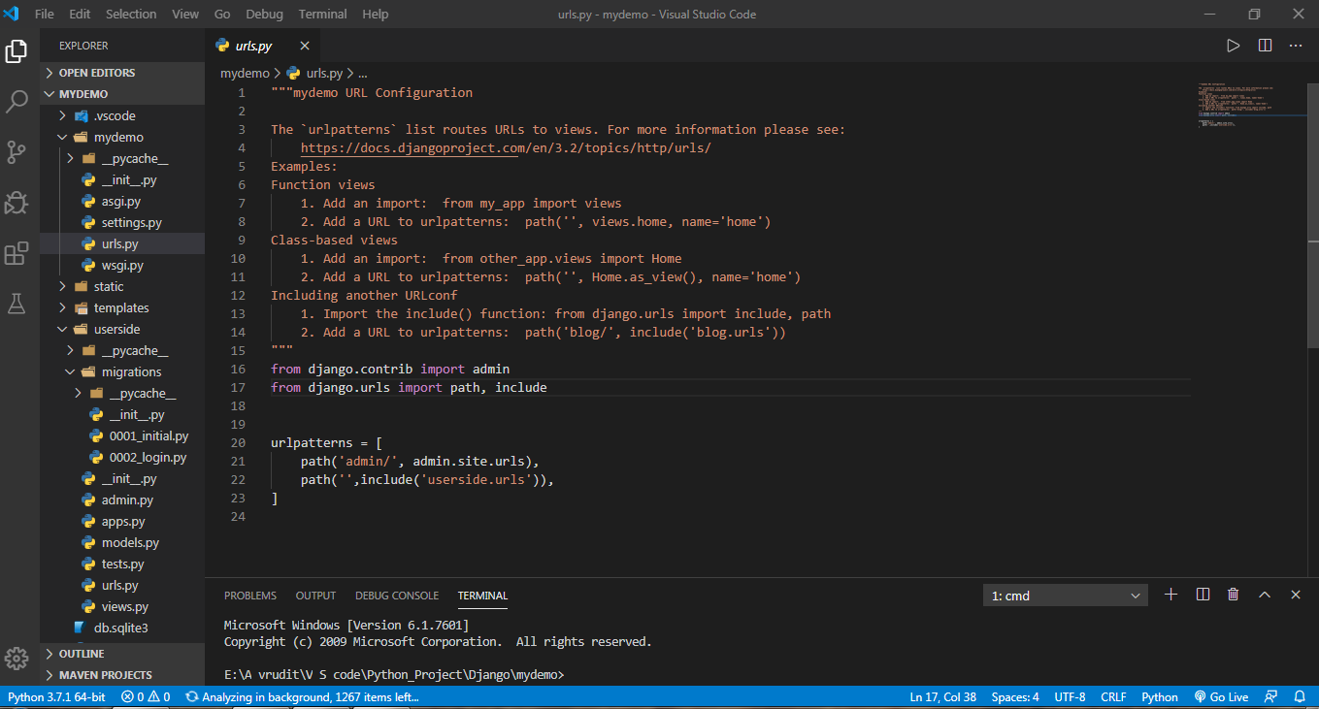

**setting.py :**

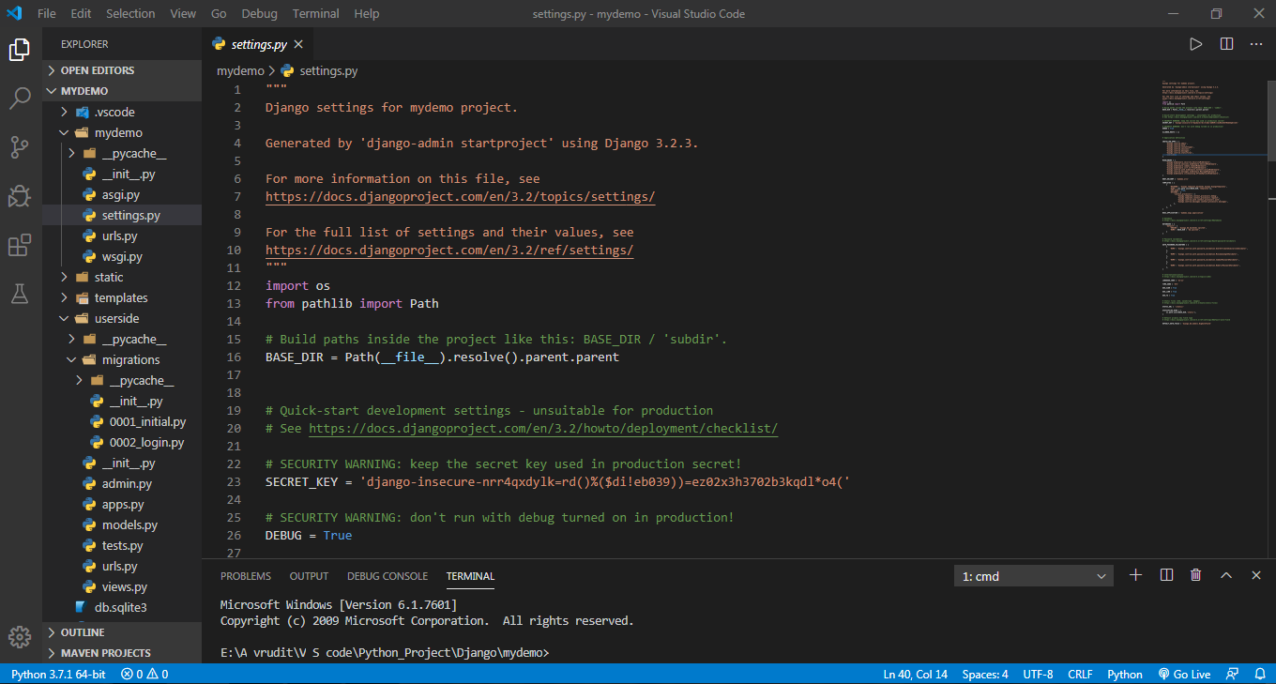

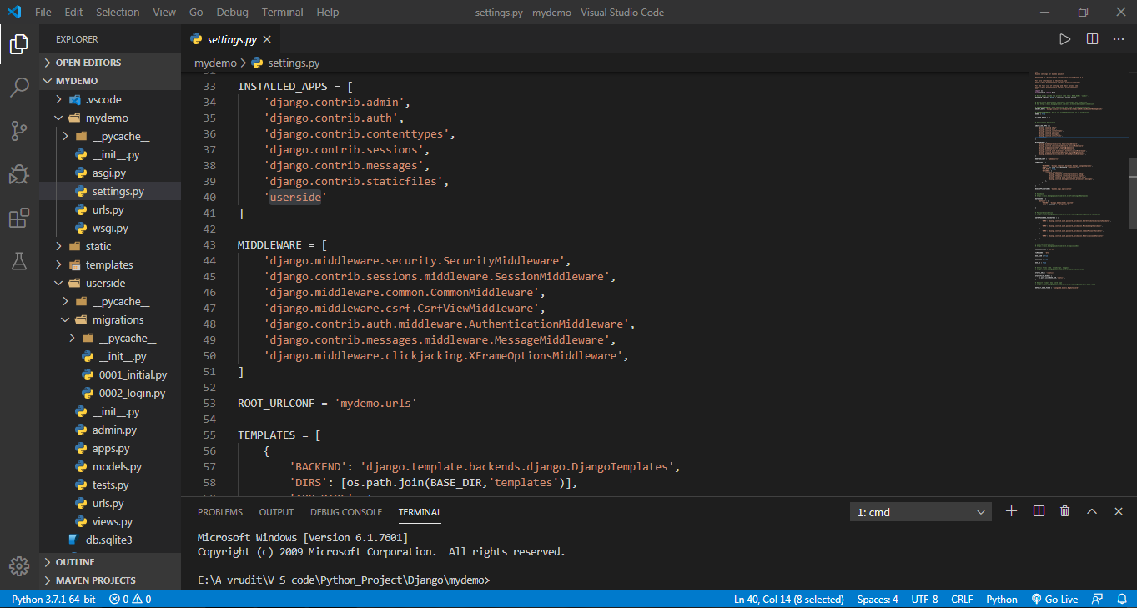

**urls.py ( userside application ) :**

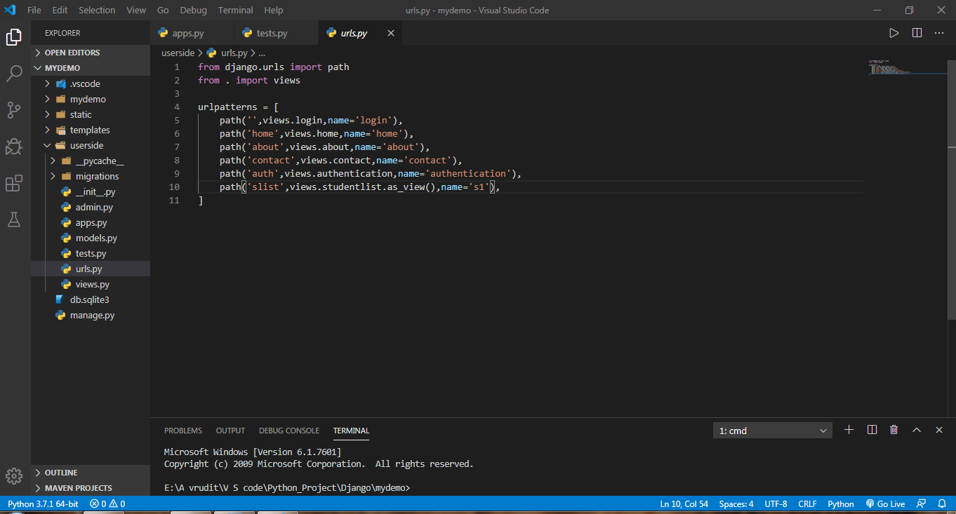

**views.py ( userside application ) :**

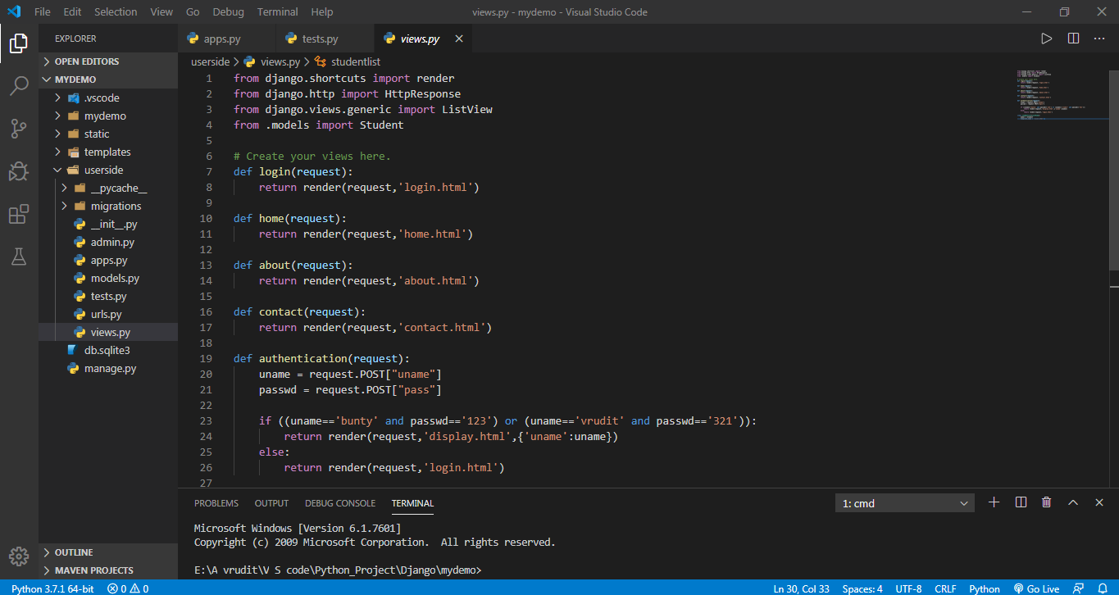

**apps.py ( userside application ) :**

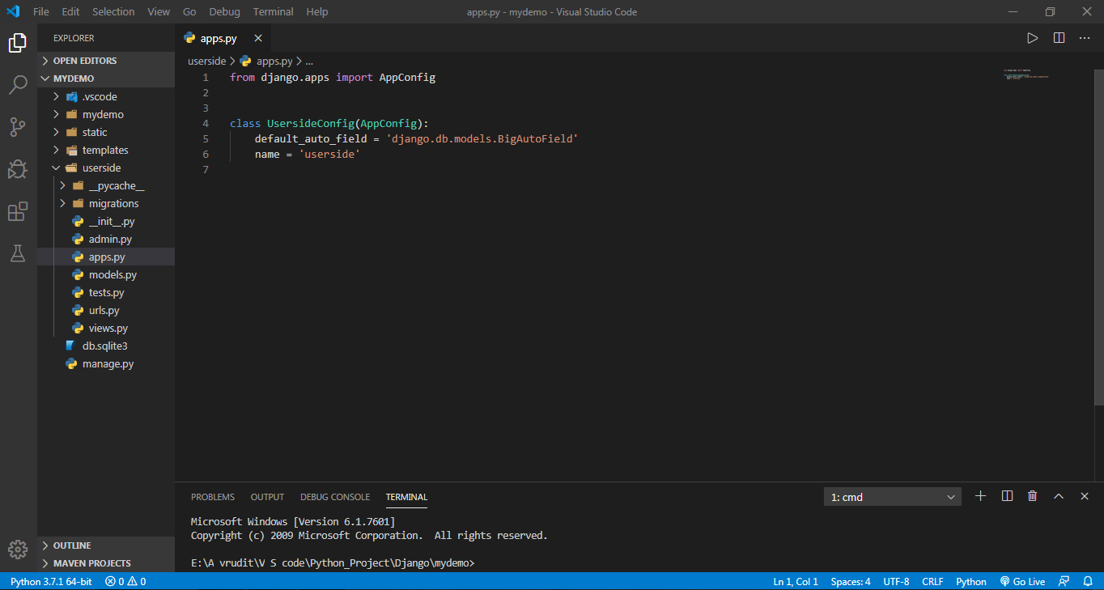

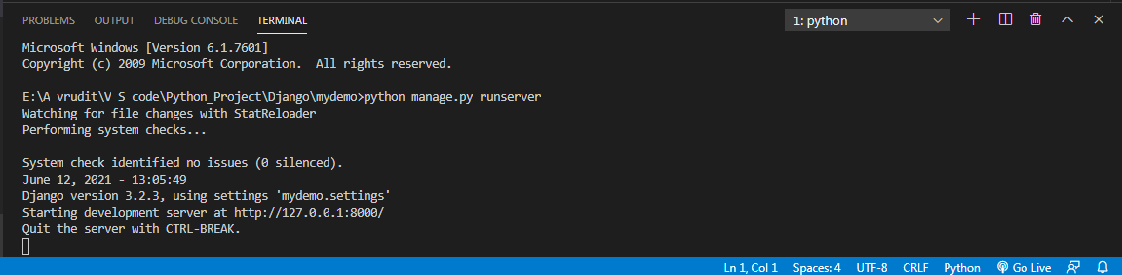

**9. HTML Pages and Theme Integration in Django :**

* As we all know HTML pages play a crucial role in any website in terms of attraction and apealing feeling.
* Infact every website must contain certain HTML pages regardless of technology in which it is made i.e. Spring, Flask, Django, Servlet, etc.
* In Django also, we can put numbers of HTML pages in our website.
* But for that we have to follow well-define procedure.
* We have to create a separate folder named as “ **templates** ”.
* After that we have to register that folder inside **urls.py** and define that in **views.py.**
* In same way, we can use CSS as well.
* Above all, we can also integate a ready-made theme . scriplates are used for this purpose.
* In this session we downloaded one theme named “ **stampa-like** ” .
* First of all we had to downloaded zip file from its official website and afterwards we needed to unzip that file.
* By doing so, we get some folders containg pictures and css files.
* In my project that folder’s name is “**static**”.
* Whole process is wounderfully described on official webiste of Django.

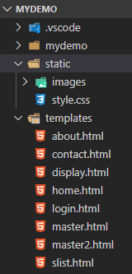

**master.html ( Theme ) :**

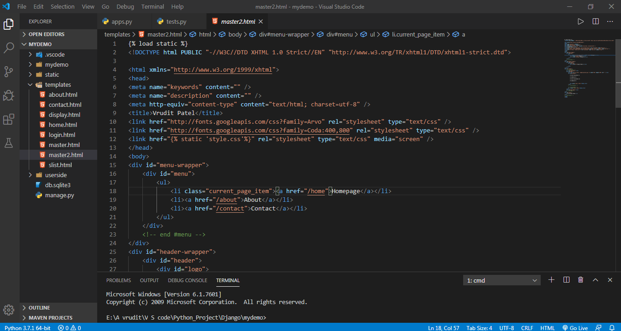

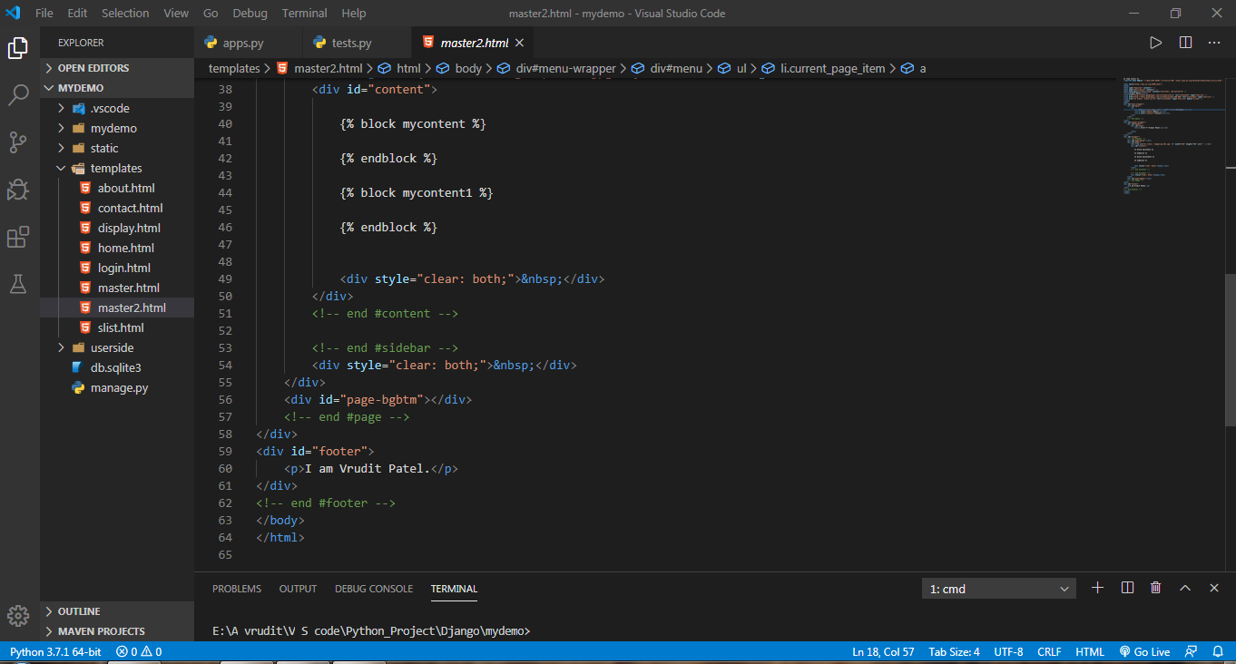

**about.html :**

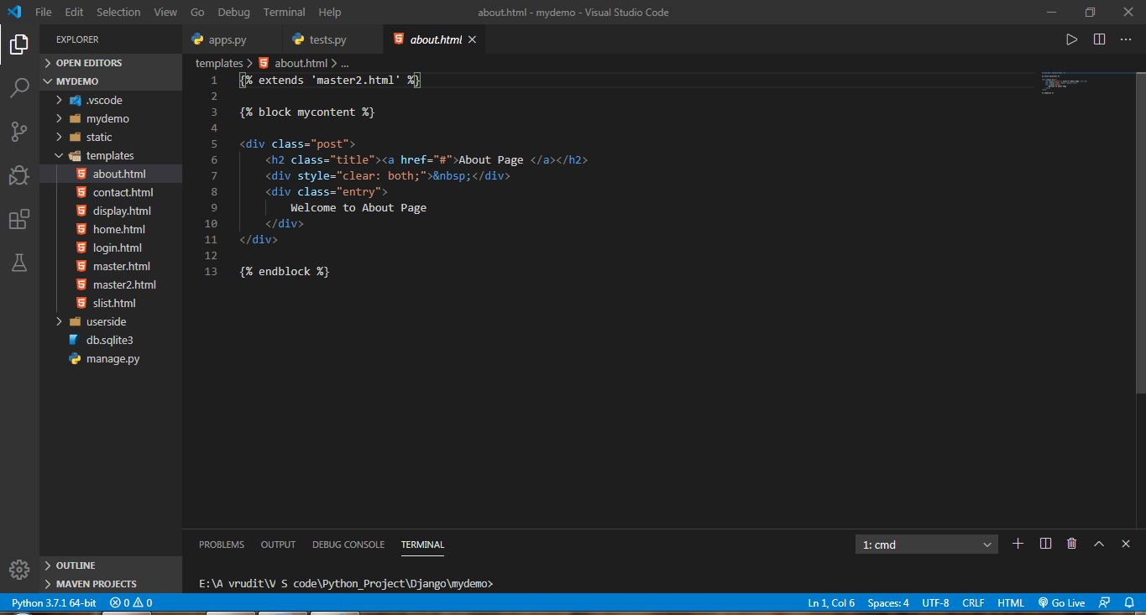

**Contact .html :**

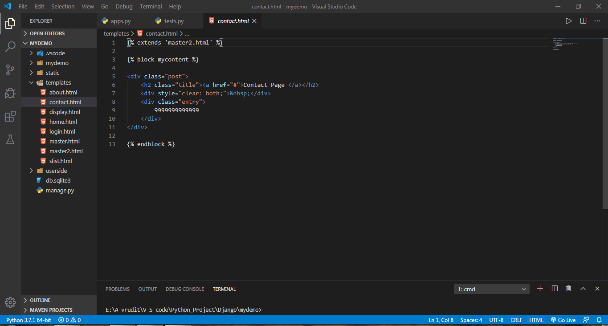

**Home.html :**

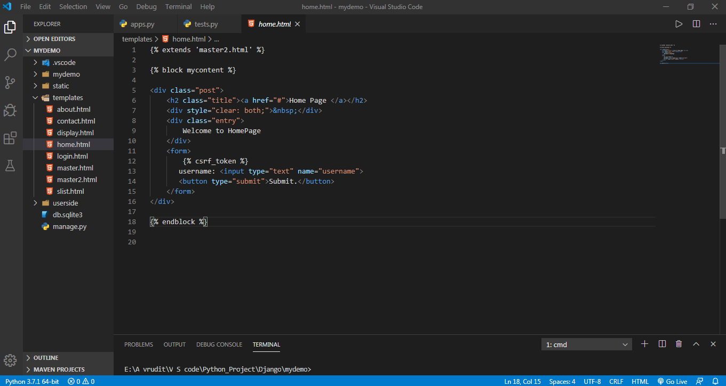

Output :

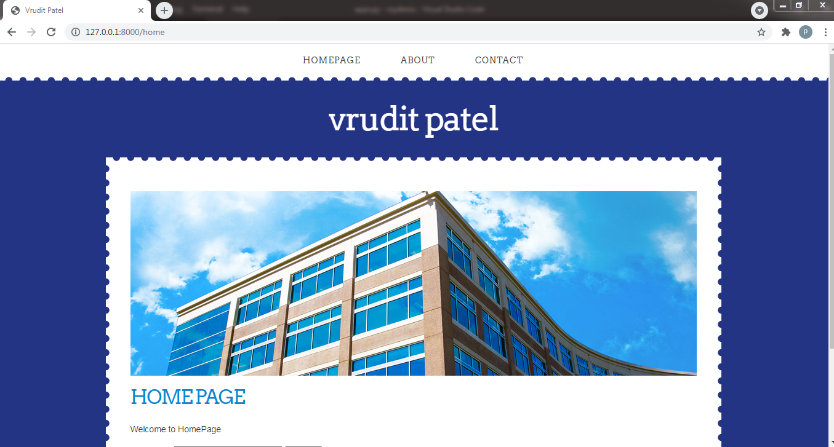

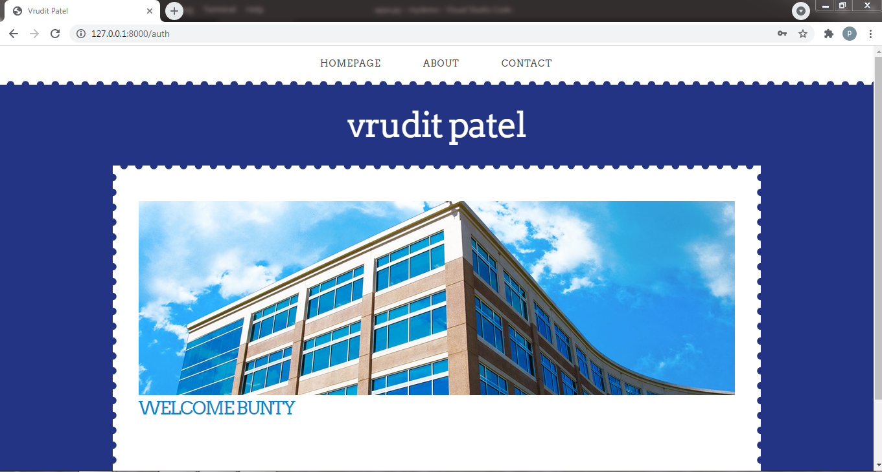

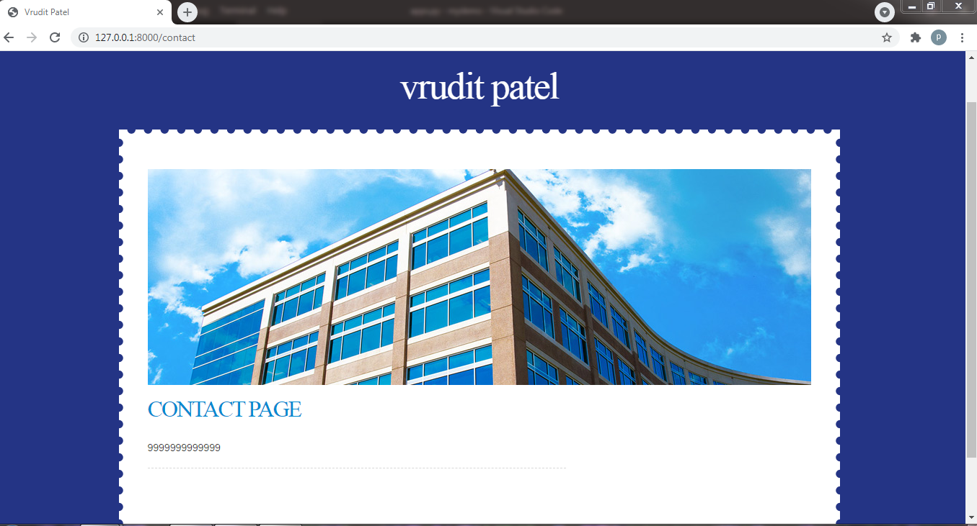

**10. Login (authentication) feature in website :**

* Countless websites possess feature of  **Login.**
* In django also, we can implement this important feature.
* For that we have to take some inputs from the users as credentials.
* For example Username and Password.
* Then we can compare that username and password with correct credentials. On that basis, we can render the user anywhere else or desired webpage.
* In this particular website, I had implemented static feature means no databse needed for authentication.
* Here is the function for authentication :

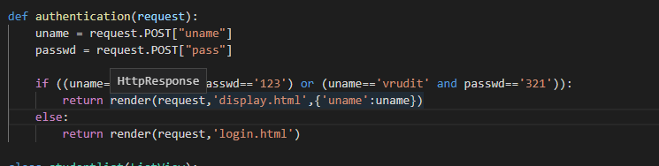

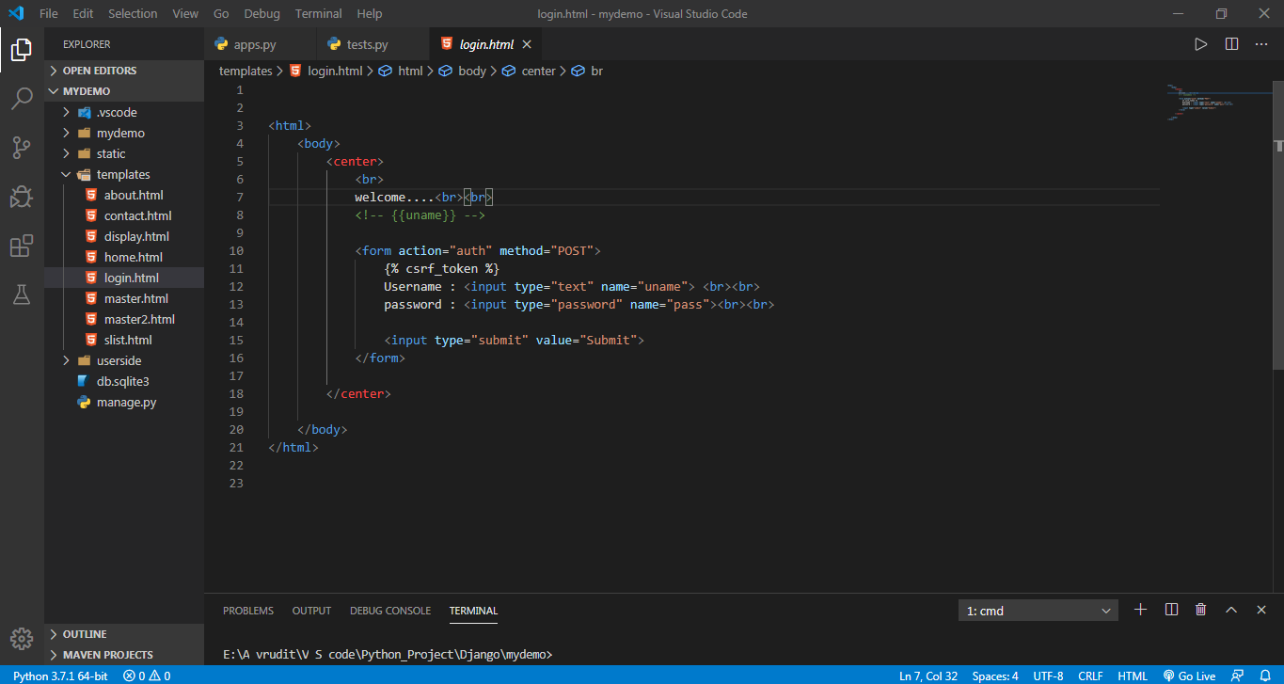

Output :

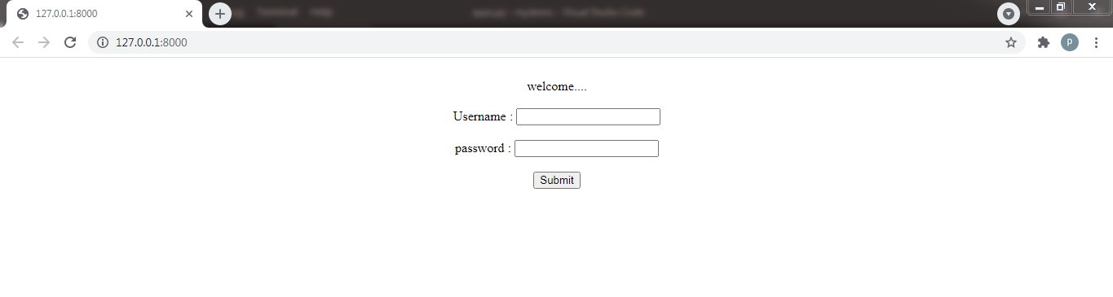

**11. Admin panel and database (sqlite3) :**

* One of the most important feature is that django provide in-built **admin panel**
* Thus developers are not longer required to utilize resources in admin panel.
* Django’s admin panel is very easy to use and userfriendly.
* We can perform almost all tasks from that admin panel.
* But in order to access admin panel we have to become **Super User**.
* We can be super user from the command prompt.
* For database, Django initially provide a small database- **sqlite3**.
* Again to access that database we have to register in **settings.py** in main folder.
* Moreover, we have to create separate file named as  **model.py**.
* In this file we can create function for each table inside sqlite3 databse.
* In short, if we have 3 tables in database, then we have to make 3 functions in **models.py**.
* After creating or changing the model.py, we have to perform one more task and that is **migration**.
* We can do this task from the command prompt itself.
* The command is :
* **python manage.py makemigration**
* **python manage.py migrate**
* **folder structure :**

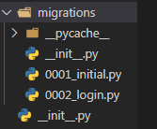

**UI of Admin panel :**

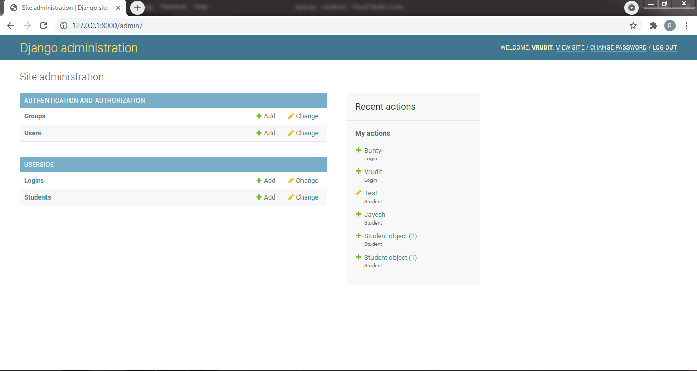

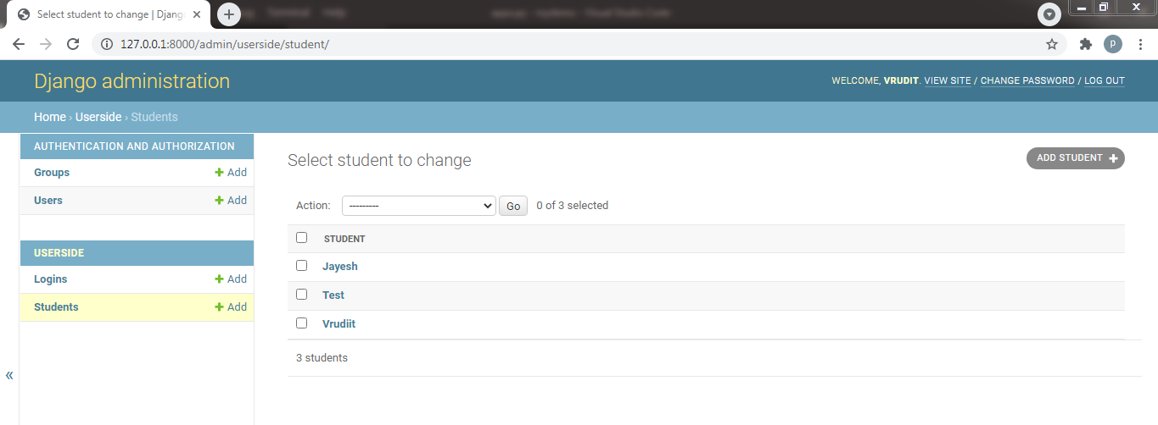

**model.py :**

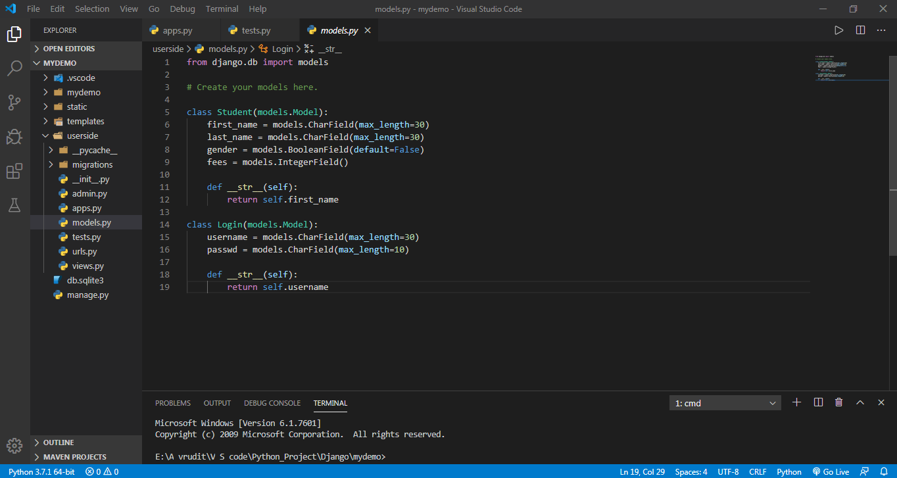

**THANK YOU…!**